1. The Developer will receive an email with the coupon code, which is a combination of 16 letters and digits. The following is an example:
XXXX-XXXX-XXXX-XXXX
2. Click the link below to register and log in on Huawei Cloud
https://auth.huaweicloud.com/authui/login.html?service=https://account.huaweicloud.com/usercenter/#/login
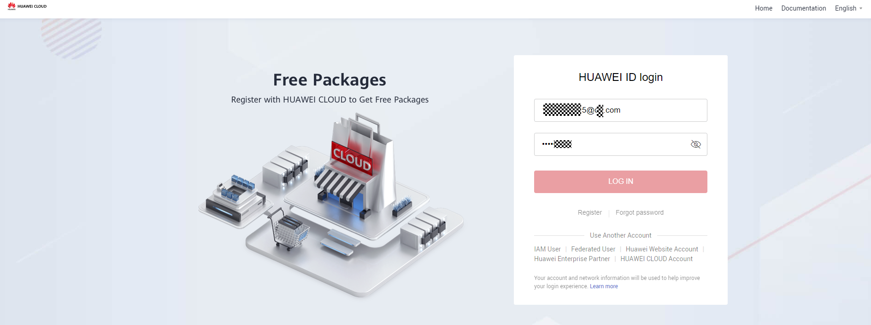
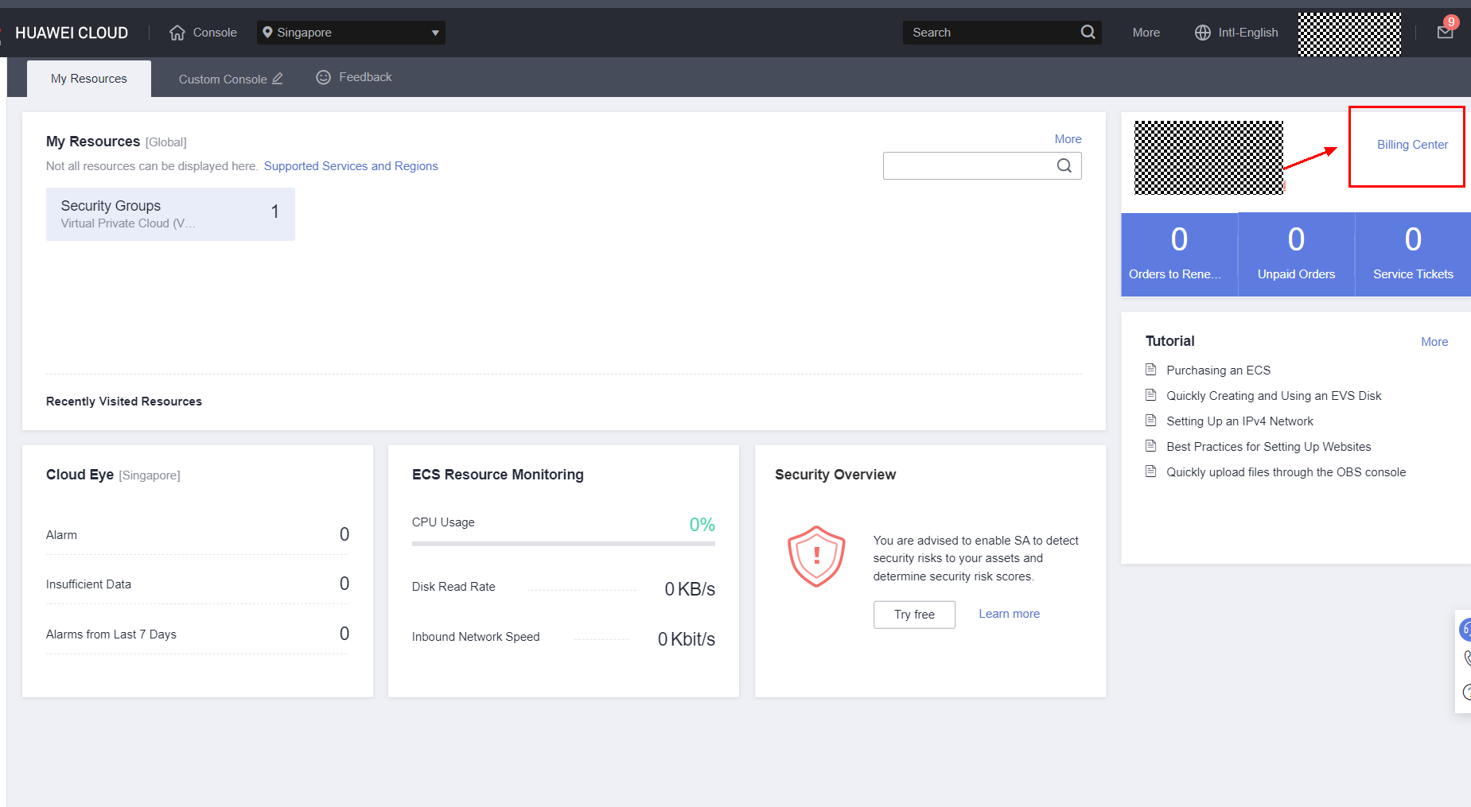
3.On the console homepage, Click Billing Center
4. Find the navigation bar on the left side and click Promotion to Coupons
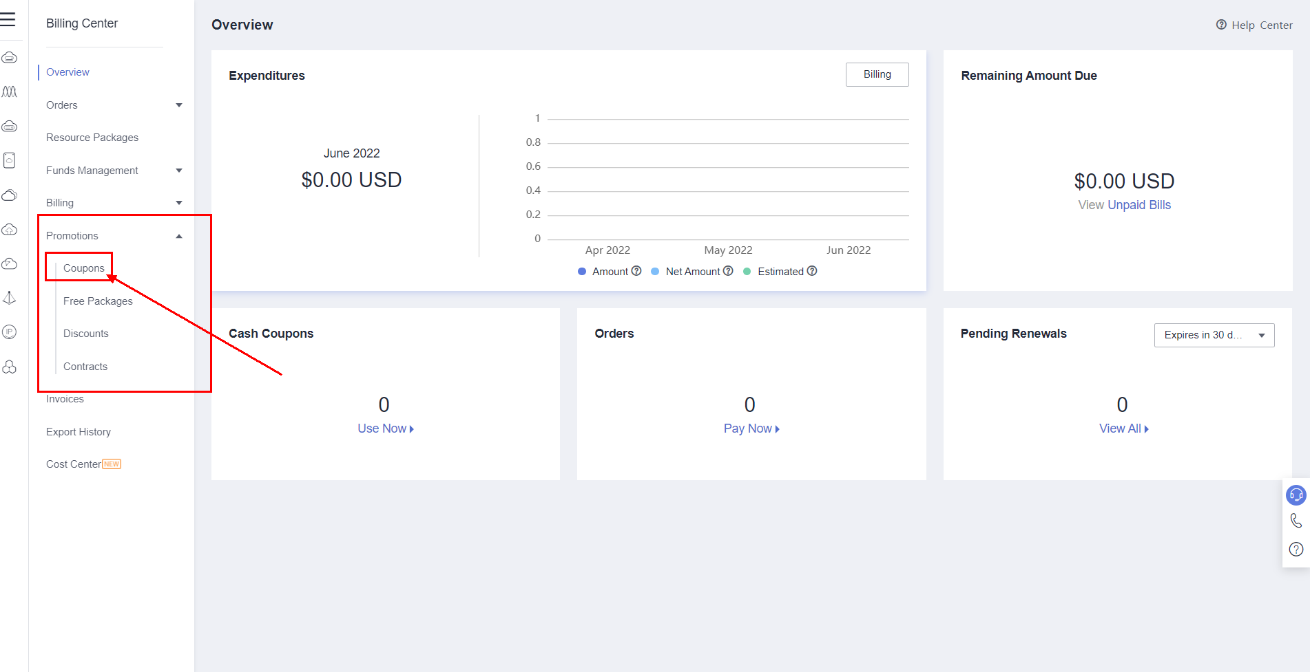
5. Click Activate Coupon, input 16-digit redemption code, then click Activate
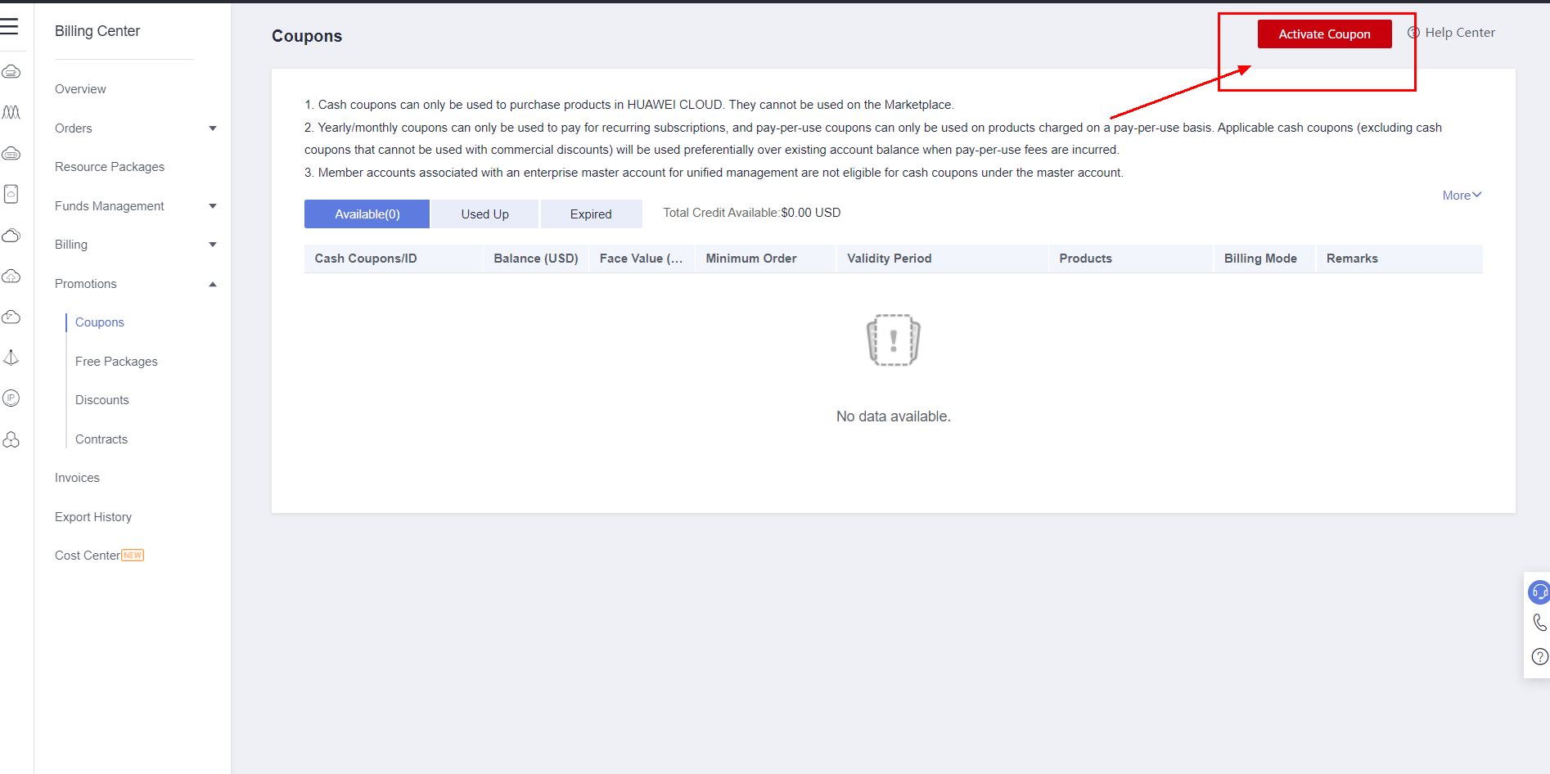
6. Then Developer can find the coupon in category.
